**Button with Image, Button with Listener**

**1. My ButtonDemo**

**activity_main.xml**

*<?***xml version="1.0" encoding="utf-8"***?>*<**LinearLayout xmlns:android="http://schemas.android.com/apk/res/android"  
 xmlns:tools="http://schemas.android.com/tools"  
 android:id="@+id/activity_main"  
 android:layout_width="match_parent"  
 android:layout_height="match_parent"  
 android:gravity="center"  
 tools:context="com.example.ju.mybuttondemo.MainActivity"**>  
  
<**Button  
 android:textAllCaps="false"  
 android:layout_margin="5dp"  
 android:layout_width="wrap_content"  
 android:layout_height="wrap_content"  
 android:text="@string/button_name"  
 android:textSize="20sp"  
 android:textStyle="bold"** />  
<**ImageButton  
 android:layout_margin="5dp"  
 android:layout_width="wrap_content"  
 android:layout_height="wrap_content"  
 android:src="@drawable/login"** />  
  
 <**Button  
 android:textAllCaps="false"  
 android:layout_margin="10dp"  
 android:textSize="20sp"  
 android:layout_width="wrap_content"  
 android:layout_height="wrap_content"  
 android:text="@string/button_name"  
 android:drawableLeft="@drawable/login"** />  
</**LinearLayout**>

**strings.xml**

<**resources**>  
 <**string name="app_name"**>My ButtonDemo</**string**>  
 <**string name="button_name"**>Login</**string**>  
</**resources**>

**MainActivity.java**

**package** com.example.ju.mybuttondemo;  
  
**import** android.support.v7.app.AppCompatActivity;  
**import** android.os.Bundle;  
  
**public class** MainActivity **extends** AppCompatActivity {  
  
 @Override  
 **protected void** onCreate(Bundle savedInstanceState) {  
 **super**.onCreate(savedInstanceState);  
 setContentView(R.layout.***activity_main***);  
 }  
}

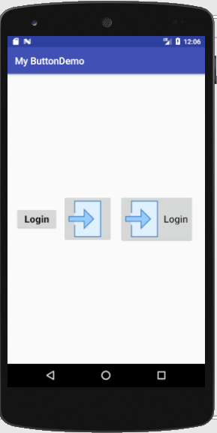

**2. My ButtonWithListener**

**activity_main.xml**

*<?***xml version="1.0" encoding="utf-8"***?>*<**LinearLayout xmlns:android="http://schemas.android.com/apk/res/android"  
 xmlns:tools="http://schemas.android.com/tools"  
 android:id="@+id/activity_main"  
 android:layout_width="match_parent"  
 android:layout_height="match_parent"  
 android:gravity="center"  
 android:orientation="vertical"  
 tools:context="com.example.ju.mybuttonwithlistener.MainActivity"**>  
  
 <**Button  
 android:id="@+id/loginButtonId"  
 android:textAllCaps="false"  
 android:layout_margin="10dp"  
 android:textSize="30sp"  
 android:layout_width="wrap_content"  
 android:layout_height="wrap_content"  
 android:text="@string/button_name"  
 android:drawableLeft="@drawable/login"** />

<**TextView  
 android:id="@+id/textViewId"  
 android:layout_width="wrap_content"  
 android:layout_height="wrap_content"  
 android:layout_margin="10dp"  
 android:textSize="20sp"**/>  
  
 </**LinearLayout**>

**strings.xml**

<**resources**>  
 <**string name="app_name"**>My ButtonWithListener</**string**>  
 <**string name="button_name"**>Login</**string**>  
</**resources**>

**MainActivity.java**

**package** com.example.ju.mybuttonwithlistener;  
  
**import** android.support.v7.app.AppCompatActivity;  
**import** android.os.Bundle;  
**import** android.view.View;  
**import** android.widget.Button;  
**import** android.widget.TextView;

**public class** MainActivity **extends** AppCompatActivity {  
  
 **int count**=0;  
 **private** Button **loginButton**;  
 **private** TextView **textView**;  
  
 @Override  
 **protected void** onCreate(Bundle savedInstanceState) {  
 **super**.onCreate(savedInstanceState);  
 setContentView(R.layout.***activity_main***);  
  
 **loginButton** = (Button) findViewById(R.id.***loginButtonId***);  
 **textView** = (TextView) findViewById(R.id.***textViewId***);  
  
 **loginButton**.setOnClickListener(**new** View.OnClickListener() {

@Override  
 **public void** onClick(View v) {  
  
 **count**++;  
 **textView**.setText(**"Button is Clicked "** +**count** +**" Times"**);  
 }  
 });  
 }  
}

